Amrita Viswa Vidhyapeetham – Nagercoil campus

Amrita School of Computing

Semester-III

23AID206- Introduction to Computer Networks

Mini Project

Name:A.Pranathi
Roll no:NC.AI.U4AID25005

TRADITIONAL NATWORKS TO SDN (SOFTWARE DEFINED NETWORKING)

ABSTRACT:
Traditional computer networks rely on dedicated networking devices such as routers, switches, and firewalls, where the control and data forwarding functions are tightly integrated. As networks become larger and more complex, managing these devices individually becomes difficult, time-consuming, and less flexible. Traditional networks also face challenges such as limited programmability, complex configuration, inefficient resource utilization, and difficulty in adapting to changing network requirements.
Software Defined Networking (SDN) provides a modern approach to overcome these limitations by separating the control plane from the data plane. In SDN, the control logic is centralized in an SDN controller, while network devices mainly perform packet forwarding based on instructions received from the controller. This separation makes the network programmable, flexible, and easier to manage.
This mini project, “Traditional Networks to SDN (Software Defined Networking),” studies the evolution from traditional network architecture to SDN-based architecture. It explains the limitations of traditional networks, the basic architecture and components of SDN, and the role of the SDN controller and communication protocols. The project also compares traditional networking with SDN in terms of network management, scalability, flexibility, automation, and security. The study demonstrates how SDN can provide centralized control and dynamic network management, making it suitable for modern data centers, cloud environments, enterprise networks, and other large-scale networking applications.
INTRODUCTION:
Computer networks play an important role in modern communication by connecting computers, servers, mobile devices, and other systems to share data and resources. Traditionally, networks have been built using physical devices such as routers, switches, firewalls, and access points. In a traditional network, each device has its own control and configuration mechanisms, and network administrators need to configure and manage these devices individually. Although this approach has been effective for many years, the increasing size and complexity of modern networks have created several challenges.
Traditional networking follows a distributed architecture in which the control plane and data plane are generally present within the same networking device. The control plane determines how packets should be handled, while the data plane forwards packets according to those decisions. Since these functions are closely integrated, making changes to the network often requires configuring multiple devices separately. This can result in increased management complexity, configuration errors, slower deployment, and difficulty in responding quickly to changing network requirements.
The growth of cloud computing, data centers, Internet of Things (IoT), virtualization, and high-speed communication has increased the demand for networks that are more flexible, programmable, and easier to manage. To address these requirements, Software Defined Networking (SDN) was introduced as a new approach to network management. SDN separates the control plane from the data plane and moves the network control logic to a centralized software-based SDN controller.
In an SDN environment, network devices primarily perform packet forwarding, while the controller manages and determines network behavior. The controller can communicate with switches and other network devices through suitable interfaces and protocols. This centralized approach allows administrators to program the network, automate configurations, monitor traffic, and dynamically modify network behavior according to requirements.
The transition from traditional networks to SDN represents an important change in the way networks are designed and managed. Instead of configuring every device independently, administrators can use centralized software-based control to manage network resources more efficiently. SDN can improve flexibility, scalability, automation, programmability, and network visibility, making it suitable for modern networking environments.
This project, “Traditional Networks to SDN (Software Defined Networking),” focuses on understanding this transition and the differences between traditional networking and SDN. It examines the limitations of traditional networks, the architecture and components of SDN, the role of the SDN controller, and the advantages and challenges associated with SDN. The project aims to provide a clear understanding of how SDN addresses the limitations of traditional networking and supports the requirements of modern computer networks.
PROBLEM STATEMENT:
Traditional computer networks are difficult to configure, manage, and monitor because network devices operate independently and require individual configuration. As network size and traffic increase, this leads to complex management, configuration errors, slow changes, limited flexibility, and inefficient utilization of network resources.
LITERATURE REVIEW:
1. Ayodele and Buttigieg – “SDN as a Defence Mechanism: A Comprehensive Survey” (2023/2024)
Ayodele and Buttigieg presented a comprehensive survey of Software Defined Networking as a mechanism for network defence. The study discussed the limitations of traditional networks, particularly their vendor-specific nature and limited flexibility and customization. It examined how SDN can provide centralized and programmable network control for addressing security threats. The paper also reviewed existing SDN-based defence mechanisms and identified their advantages, limitations, and future research directions. This study is relevant to the present project because it highlights the limitations of traditional network management and the flexibility provided by SDN.
2. Faezi and Shirmarz – “A Comprehensive Survey on Machine Learning using in Software Defined Networks (SDN)” (2023)
Faezi and Shirmarz conducted a comprehensive survey on the integration of Machine Learning with Software Defined Networking. The study explained how SDN simplifies network architecture by separating the control plane from the data plane. It examined different applications of machine learning in SDN and discussed how intelligent techniques can improve network management and decision-making. The paper is relevant to this project because it demonstrates how the programmable nature of SDN can support advanced and intelligent network management.
3. Khan et al. – “Data Plane Failure and its Recovery Techniques in SDN: A Systematic Literature Review” (2023)
Khan et al. presented a systematic literature review of data-plane failures and recovery techniques in Software Defined Networks. The study analyzed different types of failures that can affect SDN data planes and examined techniques used to recover network connectivity and maintain reliable communication. The research highlights the importance of reliability and fault recovery in SDN environments. This study is relevant to the project because reliability is an important factor when transitioning from traditional networks to software-defined network architectures.
4. Kim et al. – “Enhancing Security in SDN: Systematizing Attacks and Defenses from a Penetration Perspective” (2024)
Kim et al. studied security threats and defense mechanisms in Software Defined Networking from a penetration-testing perspective. The research examined attacks that can target different components of SDN and organized existing attack and defense techniques. The authors highlighted that SDN's open and programmable architecture provides greater flexibility and a global network view, while also introducing new security concerns. This paper is relevant to the project because it provides an understanding of the security challenges that must be considered when adopting SDN.
5. Setitra et al. – “DoS/DDoS Attacks in Software Defined Networks: Current Situation, Challenges and Future Directions” (2024)
Setitra et al. reviewed Denial-of-Service (DoS) and Distributed Denial-of-Service (DDoS) attacks in Software Defined Networks. The study examined attacks across different SDN layers and discussed existing solutions for detecting and mitigating these attacks. The research also identified security challenges and future research directions. The paper is relevant to this project because it shows that although SDN provides flexible and programmable network management, its centralized architecture can introduce specific security challenges that need to be addressed.
6. Chahal, Bhandari and Behal – “DDoS Attacks & Defense Mechanisms in SDN-Enabled Cloud: Taxonomy, Review and Research Challenges” (2024)
Chahal et al. investigated DDoS attacks and defense mechanisms in SDN-enabled cloud environments. The study explained how SDN can overcome limitations of legacy networks through the separation of control and data planes, providing greater programmability and flexibility for cloud-based networks. It reviewed different DDoS attack mechanisms, defense techniques, and research challenges in SDN-enabled cloud environments. This work is relevant to the present project because it demonstrates the application of SDN in modern cloud networks and discusses both its benefits and challenges.
PROPOSED METHOD AND METHODOLOGY:
Proposed Method
The proposed method focuses on studying the transition from traditional network architecture to Software Defined Networking (SDN). The traditional network model is first analyzed to identify problems related to configuration, centralized management, flexibility, scalability, and network monitoring. The SDN architecture is then studied to understand how the separation of the control plane and data plane changes network management.
The proposed approach consists of comparing both architectures based on their network control, configuration, scalability, flexibility, programmability, and resource management. An SDN-based network can then be represented using an SDN controller and programmable switches to demonstrate centralized network control.
Methodology
The methodology followed in this project consists of the following steps:
Step 1: Study of Traditional Networks
The working architecture of traditional networks is studied, including routers, switches, control plane, and data plane. The limitations associated with individual device configuration and distributed control are identified.
Step 2: Identification of Problems
The major problems in traditional networking are identified, such as complex configuration, limited programmability, difficulty in network-wide management, scalability issues, and inefficient handling of changing network requirements.
Step 3: Study of SDN Architecture
The SDN architecture is studied by examining its major components: application plane, control plane, SDN controller, and data plane. The communication between the controller and network devices is also considered.
Step 4: SDN Network Implementation/Simulation
An SDN environment can be created using an SDN simulation or emulation platform such as Mininet, along with an SDN controller. Network switches and hosts are configured to represent a programmable network environment.
Step 5: Comparison
Traditional networking and SDN are compared based on parameters such as network management, flexibility, scalability, programmability, automation, and control.
Step 6: Analysis of Results
The observations from the comparison or simulation are analyzed to determine how SDN addresses the management and flexibility challenges associated with traditional networks.
Methodology Flow
Traditional Network Study
↓
Identify Limitations
↓
Study SDN Architecture
↓
Create/Simulate SDN Environment
↓
Configure SDN Controller and Network Devices
↓
Compare Traditional Network and SDN
↓
Analyze Results and Advantages
SIMULATION:
Code:
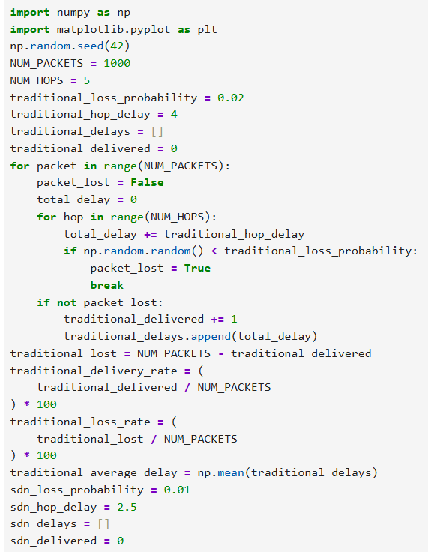
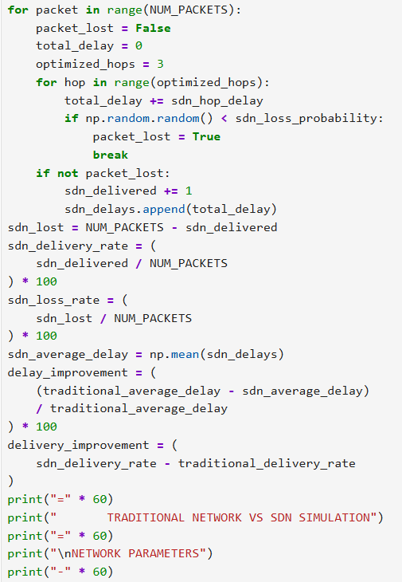
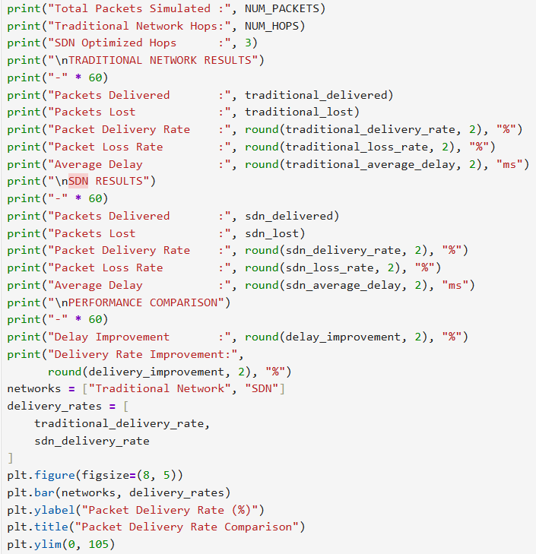
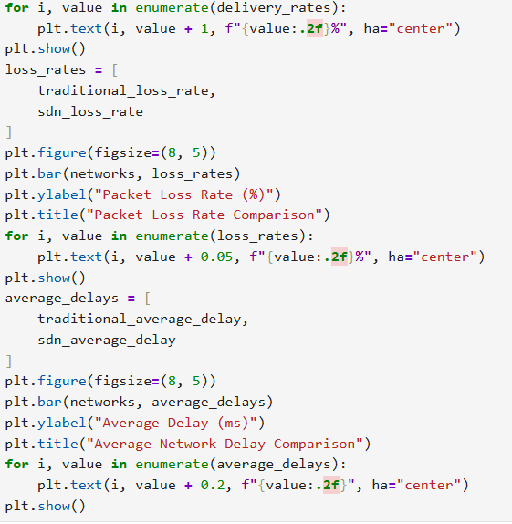
Output:
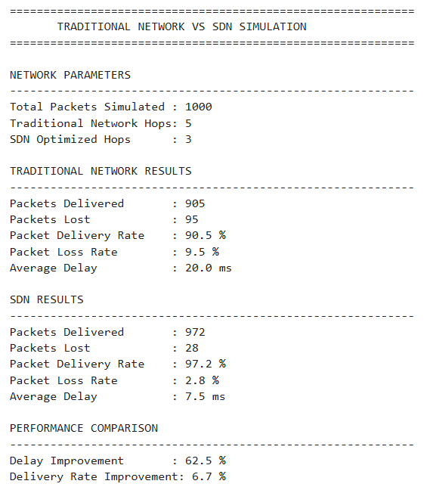
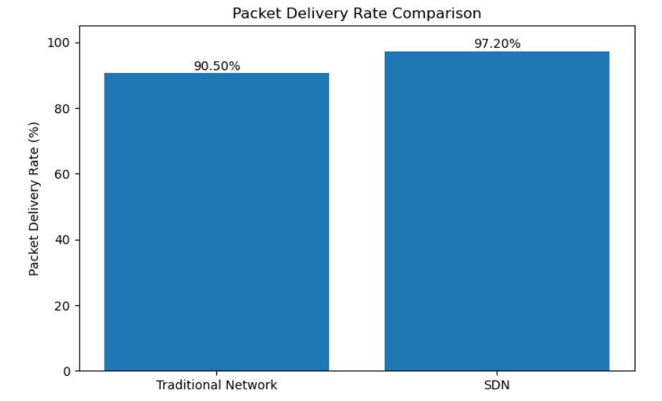
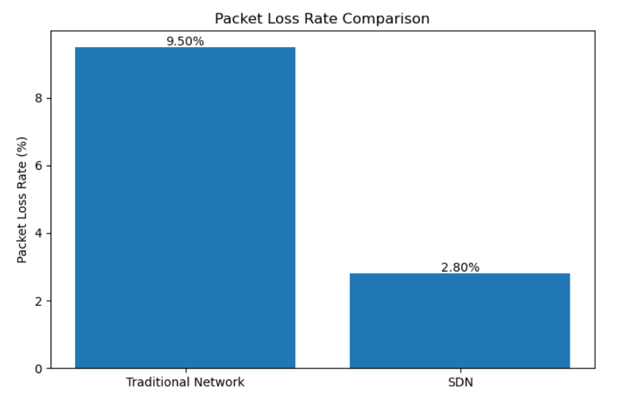
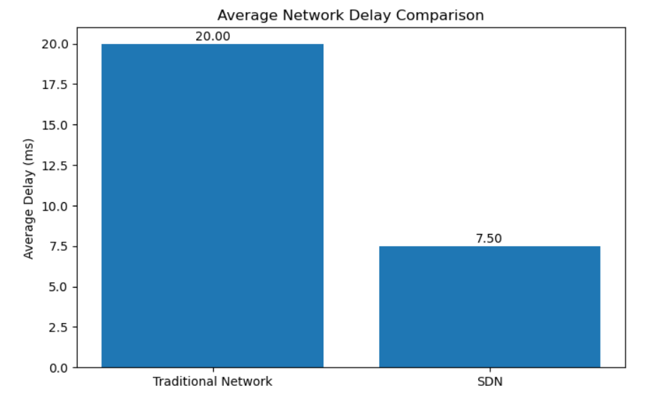
RESULTS & PERFORMANCE ANALYSIS:
The performance of the traditional network and Software Defined Networking (SDN) was evaluated by simulating the transmission of 1000 packets. The comparison was based on packet delivery rate, packet loss rate, and average network delay.
In the traditional network, 905 packets were successfully delivered and 95 packets were lost, resulting in a packet delivery rate of 90.5% and a packet loss rate of 9.5%. The average network delay was 20 ms. The traditional network used 5 hops for packet transmission.
In the SDN network, 972 packets were successfully delivered and 28 packets were lost. This resulted in a packet delivery rate of 97.2% and a packet loss rate of 2.8%. The average network delay was 7.5 ms, with the SDN network using an optimized path of 3 hops.
The results show that SDN achieved a 6.7 percentage-point improvement in packet delivery rate compared with the traditional network. The packet loss was also reduced from 9.5% to 2.8%. The average network delay decreased from 20 ms to 7.5 ms, representing a 62.5% reduction in delay.
Overall, the simulation shows that SDN provides better performance than the traditional network under the selected simulation conditions. The use of centralized control and optimized paths helps reduce delay and packet loss while improving packet delivery.
CONCLUSION & FUTURE WORK:
Conclusion
The project studied the transition from traditional networking to Software Defined Networking (SDN). Traditional networks require individual configuration and management of network devices, which can make network management complex. The simulation compared traditional networking with SDN based on packet delivery, packet loss, and network delay.
The simulation results showed that SDN achieved a packet delivery rate of 97.2%, compared with 90.5% for the traditional network. Packet loss was reduced from 9.5% to 2.8%, while average network delay decreased from 20 ms to 7.5 ms. These results demonstrate the performance benefits of centralized control and optimized paths in the simulated SDN environment.
Future Work
The project can be extended by implementing a real SDN environment using platforms such as Mininet and an SDN controller. Future work can also include testing larger network topologies, different traffic loads, dynamic routing, network security, and failure recovery. Machine learning techniques can further be explored for intelligent traffic management and network optimization.
REFERENCES:
1.B. Ayodele and V. Buttigieg, “SDN as a Defence Mechanism: A Comprehensive Survey,” International Journal of Information Security, vol. 23, pp. 141–185, 2024. DOI: 10.1007/s10207-023-00764-1.
2.S. Faezi and A. Shirmarz, “A Comprehensive Survey on Machine Learning using in Software Defined Networks (SDN),” Human-Centric Intelligent Systems, vol. 3, pp. 312–343, 2023. DOI: 10.1007/s44230-023-00025-3.
3.N. Khan, R. Salleh, A. Koubaa, Z. Khan, M. K. Khan, and I. Ali, “Data Plane Failure and its Recovery Techniques in SDN: A Systematic Literature Review,” Journal of King Saud University - Computer and Information Sciences, vol. 35, pp. 176–201, 2023. DOI: 10.1016/j.jksuci.2023.02.001.
4.J. Kim, M. Seo, S. Lee, J. Nam, V. Yegneswaran, P. Porras, G. Gu, and S. Shin, “Enhancing Security in SDN: Systematizing Attacks and Defenses from a Penetration Perspective,” Computer Networks, vol. 241, Article 110203, 2024. DOI: 10.1016/j.comnet.2024.110203.
5.M. A. Setitra, M. Fan, I. Benkhaddra, and Z. E. A. Bensalem, “DoS/DDoS Attacks in Software Defined Networks: Current Situation, Challenges and Future Directions,” Computer Communications, vol. 222, pp. 77–96, 2024. DOI: 10.1016/j.comcom.2024.04.035.
6.J. K. Chahal, A. Bhandari, and S. Behal, “DDoS Attacks & Defense Mechanisms in SDN-Enabled Cloud: Taxonomy, Review and Research Challenges,” Computer Science Review, vol. 53, Article 100644, 2024. DOI: 10.1016/j.cosrev.2024.100644.
GitHub LINK:

